Barrel-1 (13W LED) |  |  | LEGEND | QTY
LOCATION | -
LUMINAIRE DESCRIPTION: Barrel-1 (13W LED) IP65 Surface Mounted Downlight c/w Lamp and Non-Dim Driver.
IMAGES / DIMENSIONS
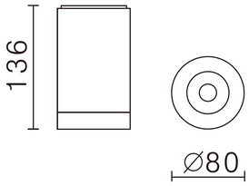 |  | 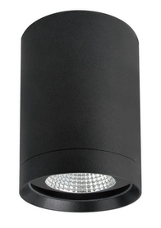
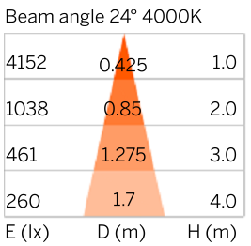
TECHNICAL SPECIFICATION
Brand / Model : BARREL-1

Luminous Source : 1 X 13W COB LED

Luminous Output : 1,340 LUMENS PER LUMINAIRE

Color Temperature : 3000K / 4000K / 5000K

Avg Luminous Life : 50,000 BURNING HOURS

Control Gear : INTEGRAL NON-DIM LED DRIVER

Material : ALUMINIUM

Diffuser : CLEAR GLASS COVER

IP Rating : IP 65

